**TUGAS UAS BAHASA PEMROGRAMAN III**



**OLEH :**

**Nama : ZEFID FRENDA FATHONI(150403010024)**

**Nama : AHMAD AFANDI (150403010026)**

**FAKULTAS SAINS DAN TEKNOLOGI**

**PROGRAM STUDI TEKNIK INFORMATIKA**

**UNIVERSITAS KANJURUHAN MALANG**

**2016**

DATABASE

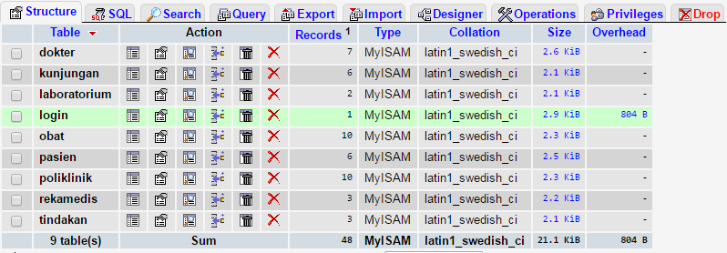

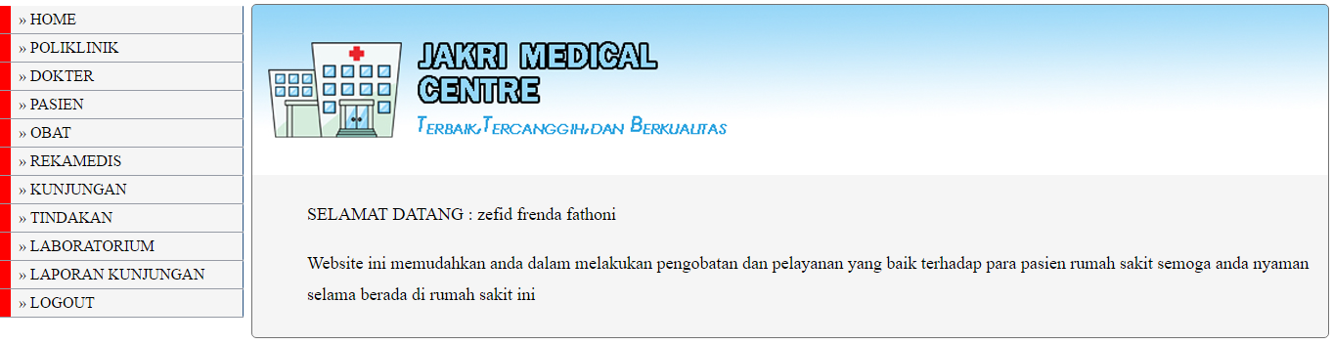

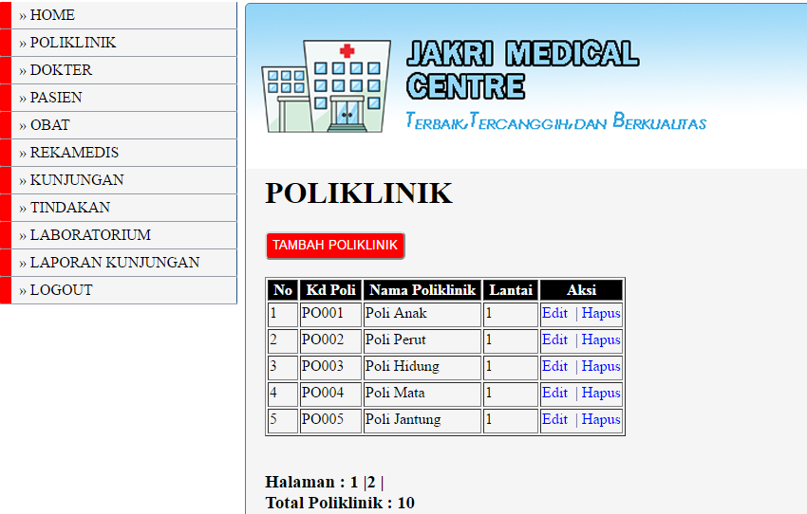

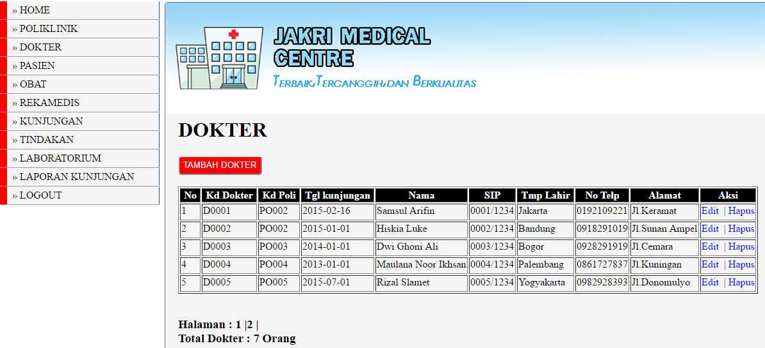

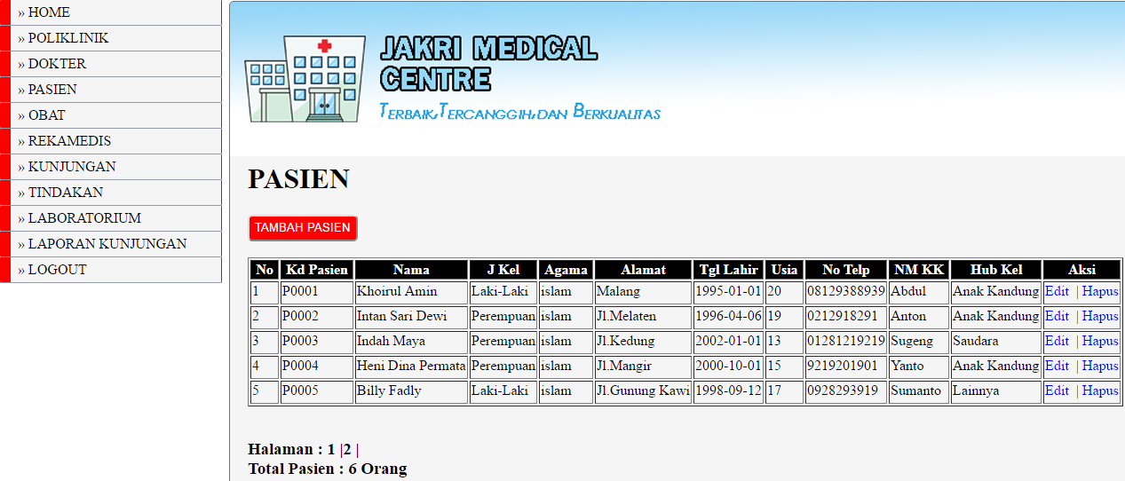

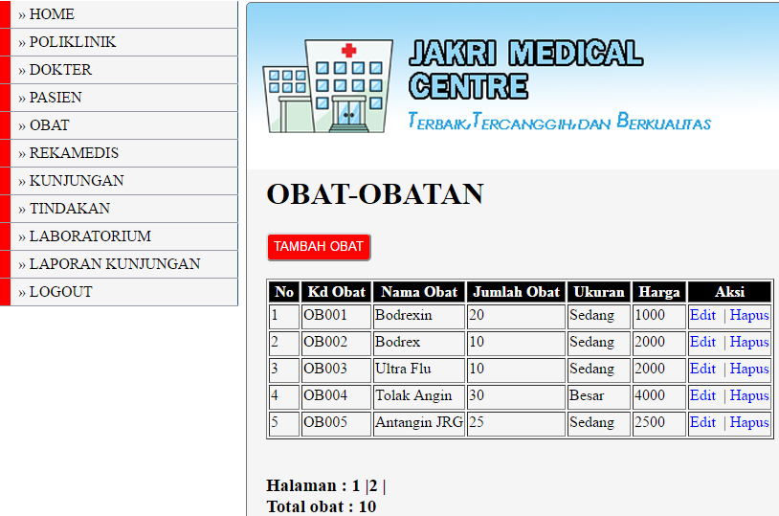

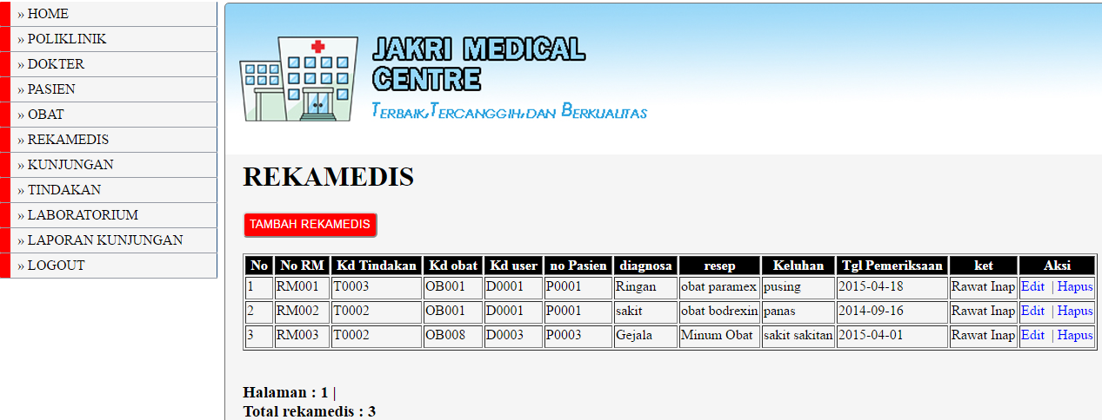

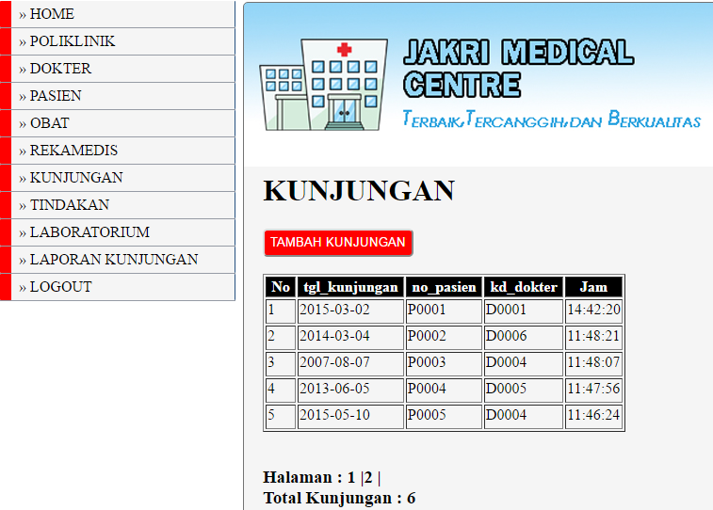

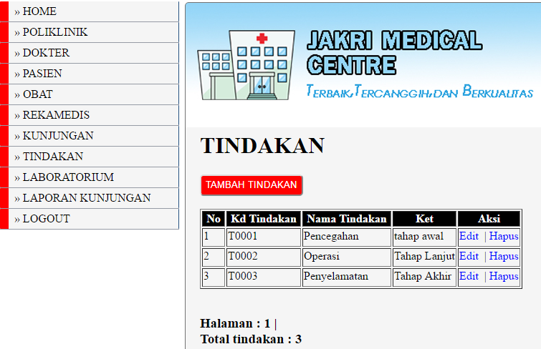

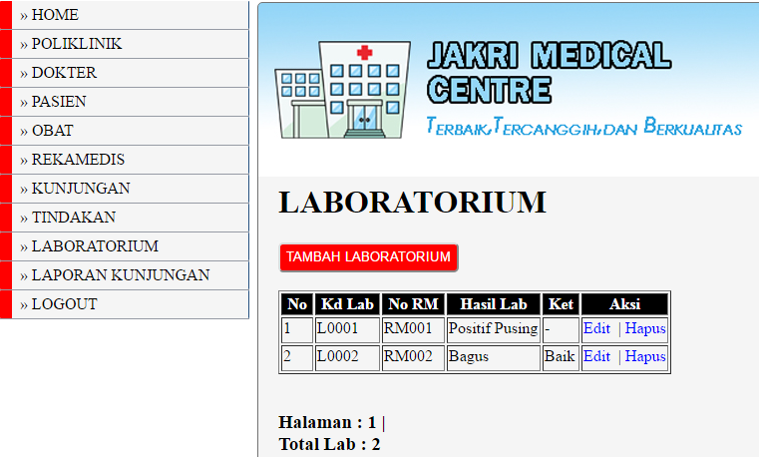

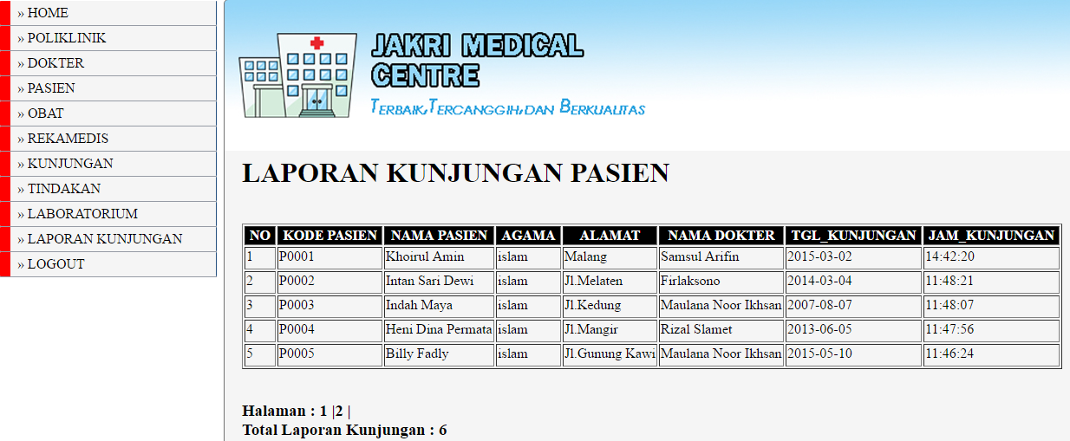

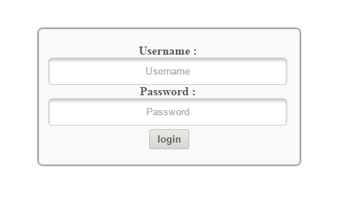

**Script**

.connect.php

<?php

$server = "localhost";

$username = "root";

$password = "";

$dbname = "rekamedis";

mysql_connect($server,$username,$password) or die ("koneksi gagal");

mysql_select_db($dbname) or die ("Database Tidak Tersedia");

?>

.dokter.php

<?php

session_start();

include"connect.php";

$nama = $_SESSION["user"];

$level = $_SESSION["level"];

if($level == 'superadmin' OR $level =='dokter'){

?>

<!DOCTYPE html PUBLIC "-//W3C//DTD XHTML 1.0 Transitional//EN" "http://www.w3.org/TR/xhtml1/DTD/xhtml1-transitional.dtd">

<html xmlns="http://www.w3.org/1999/xhtml">

<head>

<meta http-equiv="Content-Type" content="text/html; charset=utf-8" />

<title>HOME</title>

<link href="config/style.css" rel="stylesheet" type="text/css" />

</head>

<body>

<div id="menu">

<ul>

<ul>

<li><a href="dokter.php">&raquo;&nbsp;HOME</a></li>

<li><a href="dokter/poliklinik/form_poliklinik.php">&raquo;&nbsp;POLIKLINIK</a></li>

<li><a href="dokter/dokter/form_dokter.php">&raquo;&nbsp;DOKTER</a></li>

<li><a href="dokter/pasien/form_pasien.php">&raquo;&nbsp;PASIEN</a></li>

<li><a href="dokter/obat/form_obat.php">&raquo;&nbsp;OBAT</a></li>

<li><a href="dokter/rekamedis/form_rekamedis.php">&raquo;&nbsp;REKAMEDIS</a></li>

<li><a href="dokter/kunjungan/form_kunjungan.php">&raquo;&nbsp;KUNJUNGAN</a></li>

<li><a href="dokter/tindakan/form_tindakan.php">&raquo;&nbsp;TINDAKAN</a></li>

<li><a href="dokter/laboratorium/form_laboratorium.php">&raquo;&nbsp;LABORATORIUM</a></li>

<li><a href="dokter/Laporan/laporan_kunjungan.php"> &raquo;&nbsp;LAPORAN KUNJUNGAN</a></li>

<li><a href="logout.php"> &raquo;&nbsp;LOGOUT</a></li>

</ul>

</ul>

</div>

</div>

<div id="atassuper"></div>

<div id="header">

<div id="home">

<div id="content">

<p>SELAMAT DATANG : Dr. <?php echo $nama; ?></p>

<p>Website ini memudahkan anda dalam melakukan pengobatan

dan pelayanan yang baik terhadap para pasien rumah sakit

semoga anda nyaman selama berada di rumah sakit ini</p>

</p>

</div></div></div>

<?php

}

else{

?>

<script>alert("MAAF ANDA TIDAK MEMILIKI HAK AKSES HALAMAN INI");</script>

<script>window.location='index.php';</script>

<?php

}

?>

</body>

.

<!DOCTYPE html><html>

<head>

<title>Login adminstrator</title>

<link rel="stylesheet" type="text/css" href="config/style.css"/>

</head>

<body>

<div class="login">

<div class="wrap">

<div class="headlogin">

</div>

<div class="form">

<form method="post" action="proses.php">

Username : <br/>

<input type="text" name="username" placeholder="Username"/>

<br/>

Password : <br/>

<input type="password" name="password" placeholder="Password"/>

<br/>

<input type="submit" value="login" name="button"/>

</form>

</div>

</div>

</div>

</body>

</html>

.

<!DOCTYPE html><html>

<head>

<title>Login adminstrator</title>

<link rel="stylesheet" type="text/css" href="config/style.css"/>

</head>

<body>

<div class="login">

<div class="wrap">

<div class="headlogin">

</div>

<div class="form">

<form method="post" action="proses.php">

Username : <br/>

<input type="text" name="username" placeholder="Username"/>

<br/>

Password : <br/>

<input type="password" name="password" placeholder="Password"/>

<br/>

<input type="submit" value="login" name="button"/>

</form>

</div>

</div>

</div>

</body>

</html>

.

<?php

session_start();

unset($_SESSION['user']);

unset($_SESSION['level']);

session_destroy();

header("location:index.php");

?>

.

<html>

<link href="config/style.css" rel="stylesheet" type="text/css">

<body>

<div id="menu">

<ul>

<ul>

<li><a href="../../superadmin.php">&raquo;&nbsp;HOME</a></li>

<li><a href="../poliklinik/form_poliklinik.php">&raquo;&nbsp;POLIKLINIK</a></li>

<li><a href="../dokter/form_dokter.php">&raquo;&nbsp;DOKTER</a></li>

<li><a href="../pasien/form_pasien.php">&raquo;&nbsp;PASIEN</a></li>

<li><a href="../obat/form_obat.php">&raquo;&nbsp;OBAT</a></li>

<li><a href="../rekamedis/form_rekamedis.php">&raquo;&nbsp;REKAMEDIS</a></li>

<li><a href="../kunjungan/form_kunjungan.php">&raquo;&nbsp;KUNJUNGAN</a></li>

<li><a href="../tindakan/form_tindakan.php">&raquo;&nbsp;TINDAKAN</a></li>

<li><a href="../laboratorium/form_laboratorium.php">&raquo;&nbsp;LABORATORIUM</a></li>

<li><a href="../Laporan/laporan_kunjungan.php"> &raquo;&nbsp;LAPORAN KUNJUNGAN</a></li>

<li><a href="../../logout.php"> &raquo;&nbsp;LOGOUT</a></li>

</ul>

</ul>

</div>

</div>

</body>

</html>

.

<html>

<link href="config/style.css" rel="stylesheet" type="text/css">

<body>

<div id="menu">

<ul>

<ul>

<li><a href="../../dokter.php">&raquo;&nbsp;HOME</a></li>

<li><a href="../poliklinik/form_poliklinik.php">&raquo;&nbsp;POLIKLINIK</a></li>

<li><a href="../dokter/form_dokter.php">&raquo;&nbsp;DOKTER</a></li>

<li><a href="../pasien/form_pasien.php">&raquo;&nbsp;PASIEN</a></li>

<li><a href="../obat/form_obat.php">&raquo;&nbsp;OBAT</a></li>

<li><a href="../rekamedis/form_rekamedis.php">&raquo;&nbsp;REKAMEDIS</a></li>

<li><a href="../kunjungan/form_kunjungan.php">&raquo;&nbsp;KUNJUNGAN</a></li>

<li><a href="../tindakan/form_tindakan.php">&raquo;&nbsp;TINDAKAN</a></li>

<li><a href="../laboratorium/form_laboratorium.php">&raquo;&nbsp;LABORATORIUM</a></li>

<li><a href="../Laporan/laporan_kunjungan.php"> &raquo;&nbsp;LAPORAN KUNJUNGAN</a></li>

<li><a href="../../logout.php"> &raquo;&nbsp;LOGOUT</a></li>

</ul>

</ul>

</div>

</div>

</body>

</html>

.

<html>

<link href="config/style.css" rel="stylesheet" type="text/css">

<body>

<div id="menu">

<ul>

<ul>

<li><a href="../../pasien.php">&raquo;&nbsp;HOME</a></li>

<li><a href="../poliklinik/form_poliklinik.php">&raquo;&nbsp;POLIKLINIK</a></li>

<li><a href="../dokter/form_dokter.php">&raquo;&nbsp;DOKTER</a></li>

<li><a href="../pasien/form_pasien.php">&raquo;&nbsp;PASIEN</a></li>

<li><a href="../obat/form_obat.php">&raquo;&nbsp;OBAT</a></li>

<li><a href="../rekamedis/form_rekamedis.php">&raquo;&nbsp;REKAMEDIS</a></li>

<li><a href="../kunjungan/form_kunjungan.php">&raquo;&nbsp;KUNJUNGAN</a></li>

<li><a href="../tindakan/form_tindakan.php">&raquo;&nbsp;TINDAKAN</a></li>

<li><a href="../laboratorium/form_laboratorium.php">&raquo;&nbsp;LABORATORIUM</a></li>

<li><a href="../../logout.php"> &raquo;&nbsp;LOGOUT</a></li>

</ul>

</ul>

</div>

</div>

</body>

</html>

.

<?php

session_start();

include"connect.php";

$nama = $_SESSION["user"];

$level = $_SESSION["level"];

if($level == 'superadmin' OR $level == 'dokter' OR $level == 'pasien'){

?>

<!DOCTYPE html PUBLIC "-//W3C//DTD XHTML 1.0 Transitional//EN" "http://www.w3.org/TR/xhtml1/DTD/xhtml1-transitional.dtd">

<html xmlns="http://www.w3.org/1999/xhtml">

<head>

<meta http-equiv="Content-Type" content="text/html; charset=utf-8" />

<title>HOME</title>

<link href="config/style.css" rel="stylesheet" type="text/css" />

</head>

<body>

<div id="menu">

<ul>

<ul>

<li><a href="pasien.php">&raquo;&nbsp;HOME</a></li>

<li><a href="pasien/poliklinik/form_poliklinik.php">&raquo;&nbsp;POLIKLINIK</a></li>

<li><a href="pasien/dokter/form_dokter.php">&raquo;&nbsp;DOKTER</a></li>

<li><a href="pasien/pasien/form_pasien.php">&raquo;&nbsp;PASIEN</a></li>

<li><a href="pasien/obat/form_obat.php">&raquo;&nbsp;OBAT</a></li>

<li><a href="pasien/rekamedis/form_rekamedis.php">&raquo;&nbsp;REKAMEDIS</a></li>

<li><a href="pasien/kunjungan/form_kunjungan.php">&raquo;&nbsp;KUNJUNGAN</a></li>

<li><a href="pasien/tindakan/form_tindakan.php">&raquo;&nbsp;TINDAKAN</a></li>

<li><a href="pasien/laboratorium/form_laboratorium.php">&raquo;&nbsp;LABORATORIUM</a></li>

<li><a href="logout.php"> &raquo;&nbsp;LOGOUT</a></li>

</ul>

</ul>

</div>

</div>

<div id="atassuper"></div>

<div id="header">

<div id="home">

<div id="content">

<p>SELAMAT DATANG : <?php echo $nama; ?></p>

<p>Website ini memudahkan anda dalam melakukan pengobatan

dan pelayanan yang baik terhadap para pasien rumah sakit

semoga anda nyaman selama berada di rumah sakit ini</p>

</p>

</div></div></div>

<?php

}

else{

?>

<script>alert("MAAF ANDA TIDAK MEMILIKI HAK AKSES HALAMAN INI");</script>

<script>window.location='index.php';</script>

<?php

}

?>

</body>

.proses.php

<?php

session_start();

include "connect.php";

$user = $_POST["username"];

$pass = md5($_POST["password"]);

$login = mysql_query ("SELECT * FROM login WHERE username = '$user' AND password = '$pass'");

$hasil = mysql_num_rows($login);

$row = mysql_fetch_array($login);

$kd_user = $row["kd_user"];

$nama = $row["nama_lengkap"];

$level= $row["hak_akses"];

$_SESSION["user"] = $nama;

$_SESSION["level"] = $level;

$_SESSION["kd_user"] = $kd_user;

if($level == 'superadmin'){header('location:superadmin.php');}

if($level == 'dokter'){header('location:dokter.php');}

if($level == 'pasien'){header('location:pasien.php');}

include "index.php";

?>

<script>alert("Username/Password salah");</script>

<script>window.location='index.php';</script>

<?php

?>

.superadmin.php

<?php

session_start();

include"connect.php";

$nama = $_SESSION["user"];

$level = $_SESSION["level"];

if($level == 'superadmin'){

?>

<!DOCTYPE html PUBLIC "-//W3C//DTD XHTML 1.0 Transitional//EN" "http://www.w3.org/TR/xhtml1/DTD/xhtml1-transitional.dtd">

<html xmlns="http://www.w3.org/1999/xhtml">

<head>

<meta http-equiv="Content-Type" content="text/html; charset=utf-8" />

<title>HOME</title>

<link href="config/style.css" rel="stylesheet" type="text/css" />

</head>

<body>

<div id="menu">

<ul>

<ul>

<li><a href="superadmin.php">&raquo;&nbsp;HOME</a></li>

<li><a href="superadmin/poliklinik/form_poliklinik.php">&raquo;&nbsp;POLIKLINIK</a></li>

<li><a href="superadmin/dokter/form_dokter.php">&raquo;&nbsp;DOKTER</a></li>

<li><a href="superadmin/pasien/form_pasien.php">&raquo;&nbsp;PASIEN</a></li>

<li><a href="superadmin/obat/form_obat.php">&raquo;&nbsp;OBAT</a></li>

<li><a href="superadmin/rekamedis/form_rekamedis.php">&raquo;&nbsp;REKAMEDIS</a></li>

<li><a href="superadmin/kunjungan/form_kunjungan.php">&raquo;&nbsp;KUNJUNGAN</a></li>

<li><a href="superadmin/tindakan/form_tindakan.php">&raquo;&nbsp;TINDAKAN</a></li>

<li><a href="superadmin/laboratorium/form_laboratorium.php">&raquo;&nbsp;LABORATORIUM</a></li>

<li><a href="superadmin/Laporan/laporan_kunjungan.php"> &raquo;&nbsp;LAPORAN KUNJUNGAN</a></li>

<li><a href="logout.php"> &raquo;&nbsp;LOGOUT</a></li>

</ul>

</ul>

</div>

</div>

<div id="atassuper"></div>

<div id="header">

<div id="home">

<div id="content">

<p>SELAMAT DATANG : <?php echo $nama; ?></p>

<p>Website ini memudahkan anda dalam melakukan pengobatan

dan pelayanan yang baik terhadap para pasien rumah sakit

semoga anda nyaman selama berada di rumah sakit ini</p>

</p>

</div></div></div>

<?php

}

else{

?>

<script>alert("MAAF ANDA TIDAK MEMILIKI HAK AKSES HALAMAN INI");</script>

<script>window.location='index.php';</script>

<?php

}

?>

</body>

.search.php

<?php

include "../../connect.php";

?>

<html>

<head>

<title>Pencarian Berdasarkan Kategori</title>

<link href="../../config/style.css" rel="stylesheet" type="text/css" />

</head>

<body>

<form method="POST" action="hasil.php" id="form">

<label for="txtsearch"><input type="text" name="txtsearch" placeholder="Search" required>

<select name="kategori">

<option value="">-- Cari Berdasarkan --</option>

<option value="nm_obat">Nama Obat</option>

<option value="ukuran">Ukuran</option>

</select>

<input class="submitcari" type="submit" value="Cari" name="submit"/>

</form>

</body>

</html>

.hasil.php

echo"</table>";

//Langkah ketiga:hitung total data dan halaman serta Link 1.2.3...

echo "<br>Halaman :&nbsp;";

if ( ! $_GET['input'] )

{ $search = $_POST['txtsearch']; }

else

{ $search = $_GET['input']; }

if ( ! $_GET['kombo'] )

{ $skripsi = $_POST['kategori']; }

else

{ $skripsi = $_GET['kombo'];}

$tampil2="SELECT * FROM obat WHERE $skripsi LIKE '%$search%' ORDER BY kd_obat ASC";

$hasil2=mysql_query($tampil2);

$jmldata=mysql_num_rows($hasil2);

$jmlhalaman=ceil($jmldata/$batas);

for($i=1;$i<=$jmlhalaman;$i++)

if($i!=$halaman)

{

echo"<a href=$_SERVER[PHP_SELF]?halaman=$i&input=$search&kombo=$skripsi style=color:#000>$i</a> |";

}

else

{

echo"<b>$i</b> |";

}

echo "<br>Total Pencarian dengan Kata <b>$search</b> :&nbsp;<b>$jmldata</b></p>";

?>

<br /><br />

</body>

</html>